

**Asset Practice Answers: Mathematics**

1. If the MINUTE hand of a clock is at 6, the time shown by the clock could be

A. 9:20

B. 12:00

**C. 2:30**

D. 6:00

2. Here are Namita's and Jenny's shoes



They measure the length of their classroom using their shoes. With Namita's shoes, the room is 15 'shoes' long. What could be the length of the room when measured with Jenny's shoes?

**A. 13 shoes long**

B. 15 shoes long

C. 17 shoes long

D. 19 shoes long

3. How many 50-paise coins will Tina need to buy this kite?

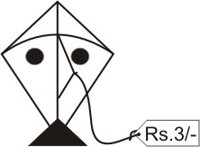

A. 3

B. 5

**C. 6**

D. 30

4. What number can fit in BOTH the boxes below to make the sentence true?

A. 0

**B. 5**

C. 8

D. 30

5.  - 6 = 14 + 5 What number comes in the empty ?

A. 6

B. 8

C. 19

**D. 25**

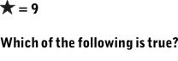

6.

A.  B. **C.** D.



7. What number comes in the empty box? 70 - 39 = - 59

A. 20

B. 50

C. 70

**D. 90**

8. What number goes in the box below to make the number sentence true?



A. 3

B. 13

C. 50

**D. 57**



9. What number comes in the empty box? 40 + 13 = 60 -

**A. 7**

B. 13

C. 17

D. 27

10. Which of the following is the same as 4 + 50 - 3?

A. 40 + 5 - 3

B. 90 - 3

C. 4 + 20

**D. 1 + 50**

11. See the number chart below. This is a '1 to 100' chart with three lines completed. The chart goes on the same way up to 100:

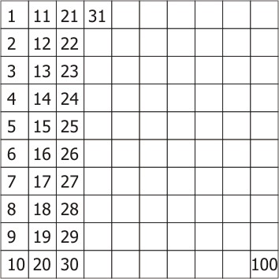

The number that comes in the box to the LEFT OF 54 in the chart is

A. 1 less than 54.

B. 1 more than 54.

**C. 10 less than 54.**

D. 10 more than 54.

12. 3 children wrote 3 different number sentences on the board.

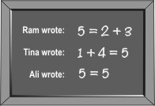

Which of the sentences are correct? **A. All three sentences are correct.**

B. Only Tina and Ali's sentences are correct.

C. Only Ali's sentence is correct.

D. Only Tina's sentence is correct.



1. C: Do you know which hand of the clock shows the minute? The longer hand! Have you seen where this hand is at 6

O'clock or 8 O'clock or 10 O'clock are any such time? At 12 right? When the time is a complete hour like 6 O'clock or 6:00,

the minute hand is always at 12. When is the minute hand at 6? At times like 1:30, 2:30, 5:30, 7:30, etc. Observe the clock at home today and see the position of the hands at different times! At 6:00 the smaller hand, that is the hour hand is at 6 and the minute hand is at 12.

2. A: Try doing this at home. Measure the length of your room using your shoe and your father's shoe. What do you observe? Since your father's shoes are longer, you can cover the length of the room with lesser number of shoes than

with your shoes, is it not? Here Jenny's shoes are longer. If the class room is 15 'shoes' long with Namita's shoe, it has to be less then 15 'shoes' long with Jenny's shoe. Of the given options, only 13 is less than 15. So the class room could be

13 'shoes' long with Jenny's shoe.

3. C: The kite costs Rs. 3. Two 50-paise coins make a rupee. So we need 2 x 3 = six 50-paise coins to make Rs. 3. So

Tina will need six 50-paise coins to buy the kite.

4. B: The meaning of = sign is that the expression to its left is equal to the expression to its right. 20 - 0 is not the same as 10 + 0. 20 - 5 = 10 + 5, which is 15? So the number in the box is 5.

20 - 30 is not the same as 10 + 30 (40). So D is incorrect.

5. D: 14 + 5 = 19. What number in the box makes



- 6 = 19? The number 19 + 6, which is 25, right? That is 25 - 6 = 14 + 5. Note that the meaning of "=" sign is that the expression to its left is equal to the expression to its right.

6. C:



stands for the number 9. Replace



by 9 in all the 4 number sentences and see which one is correct. 9 = 2 + 7, right? Hence C is the answer. 1 + 9 is 10 and not 9. So A is incorrect.

7. D: The meaning of "=" sign is that the expression on its left is equal to the expression to its right. The expression on the left, 70 - 39 is equal to 31. The expression on the right - 59 also equals 31 . What number will come in the box so that -

59 = 31? The number given by 59 + 31, which is 90, right?

8. D: From what should 27 be subtracted to get 30? Definitely the number should be greater than 30. In fact the number in the box is given by 27 + 30. If you subtract 27 from 57, the result is 30. Can you subtract 27 from 3? So D is the answer and not A.

9. A: 40 + 13 = 53. The meaning of "=" sign is that the expression to its left is equal to the expression to its right. So 60 - = 53. What number in the box makes 60 - = 53? 7, right? Hence, 40 + 13 = 60 - 7.

10. D: 4 + 50 - 3 = 54 - 3 = 51. The expression in D, 1 + 50 = 51. Thus 4 + 50 - 3 is the same as 1 + 50.

11. C: Let us take all the numbers in the first row: 1, 11, 21, 31, 41, 51, 61, 71, 81, 91. Do you see that 1 is 10 less than 11? 11 is 10 less than 21 and so on. What will be the numbers in the 4th row? 4, 14, 24, 34, 44, 54 etc. right? So the number left to 54 is 44, which is 10 less than 54.

12. A: Does not 5 equal 2 + 3? So 5 = 2 + 3 which states the same, is correct. If you take 5 kg weight in left pan and two weights of 2 kg and 3 kg in right pan, the two pans will balance each other, right? 5 equals 5. So 5 = 5 is also correct. Hence A is the answer and not D.

The meaning of "=" is that expressions on both its sides are equal. So, 2 + 3 = 1 + 4 is also correct. Think this in terms of a simple balance as shown earlier.